

**Testing for Category Part | Belayneh Mathewos**

**Testing for Category Part**

**Test Plan**

1.When retrieving item from shola database

* As much as possible to achieve the system that is at least 80% free from non-tolerable errors/defects.
* The system should be 80% free from defects

2.When seller upload his/her item

* As much as possible to achieve the system that is at least 85% free from non-tolerable errors/defects.
* The system should nearly be 85% free from defects

**Test case specifications**

1.When retrieving item from shola database

Test cases:

* If database is empty, what will happen to retrieve items.

2.When seller upload his/her item

Test cases:

* Image posting and retrieval should include all types.?
* All fields should be filled – if some field remains empty, will not be uploaded.

- tells the remaining field to the seller to fill it.

* Item name, description and category -any inputs(alphanumeric)

-If item name, … too large(can database store it?)

* Quantity, availability – integer(number) inputs
* price – double(number) input

***Sample code with simple modification***.

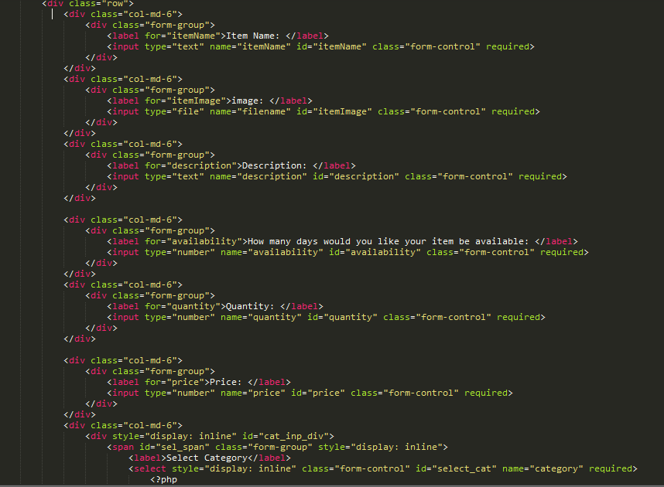

3. When a user product should be available/removed

* Within 2 second after seller uploads his products. Or as much as possible, as soon as uploader uploads his products, the product will be available for the sale.

**Results of the Test**

**THE RESULTS IN TABLE FORM**

Generally, tests of this module can be summarized as following.

**Test case for Uploading items**

|  |  |  |  |  |  |
| --- | --- | --- | --- | --- | --- |
| **TC**  **No.** | **Features** | **Description** | **Steps to Execute** | **Test Data/Input/ Expected** | **Successful** |
| 1 | Required fields | -Check the required fields by not filling any data | 1. Do not enter any value in the field 2. Click on Post button | -message should be displayed | YES |
| 2 | Required fields | -Check the required fields by not filling at least only one field | 1. Leave only one field empty 2. Click on Post button | --message should be displayed | YES |
| 3 | Required fields:  -name,  -description,  -category | -Check the required fields:  -name,  -description,  -category  by filling any input type | 1. Fill name,  description,  category by any input type with valid values in other required fields  2. Click on Post button | -S6 phone,  -smart phone with 4GB ram,..  -Phone | YES |
| 4 | Required fields:  -quantity,  -availability  -price | Check the required fields:  -quantity,  -availability  -price  by filling any input type | 1. Fil quantity,  Availability,  Price by any input type with valid values in other required fields  2. Click on Post button | -10  -60  -40000$ |  |
| 5 | Required fields:  -Image | Check the required fields:  -Image  by filling any input type | 1. Fil image by any input type with valid values in other required fields  2. Click on Post button | -will not be  Stored | YES |
| 6 | Required fields | -Check the required fields by filling all fields with valid values | 1. fill the all required fields with valid values 2. Click on Post button | -S6 phone,  -smart phone with 4GB ram,..  -Phone  -10  -60  -40000$ | -YES |
| 7 | Required fields | -Check the required fields by filling all fields with too large inputs, but valid data type | 1. enter too large inputs, but valid data types into all fields  2. Click on Post button | -Truncate  -S6 phone ..  -smart phone with 4GB ram,..  -Phone …  -10 …  -60 …  -40000…$ | -YES |

**User Guide**

**To upload your product on shola e-commerce**

After you logedin, browse to dashboard and select on <item list> in left side of the page.

Once you clicked on <Upload Item> under the table, you will get the form in which the product details will be filled.

Before you upload your items,you have to fill all fields.

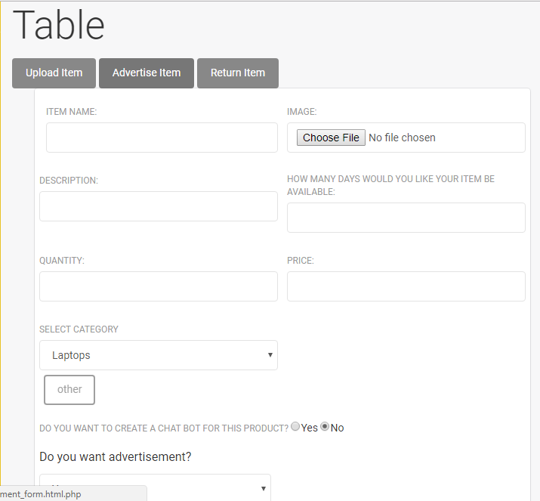

So when you <choose file> to upload your products image, the image type should be ipg, png, jpeg image types. Otherwise your product will be imageless, since the image will not be uploaded.

When you fill the <quantity >, <availability > and <price > of your product the input should be a number.

The other field can be any string.

To select the category in which your product is categorized, click the dropdown box under <select category >. If your product does not belongs to any category list, choose(click) the <other > button at the bottom of the table list page.

Finally click the <post > button to upload. You can click cancel button if you are not interested to upload the product.

Make sure that after you upload the product, you have to check whether your product is uploaded or not simply by looking your product details under <category> dropdown box or <wishlist>.

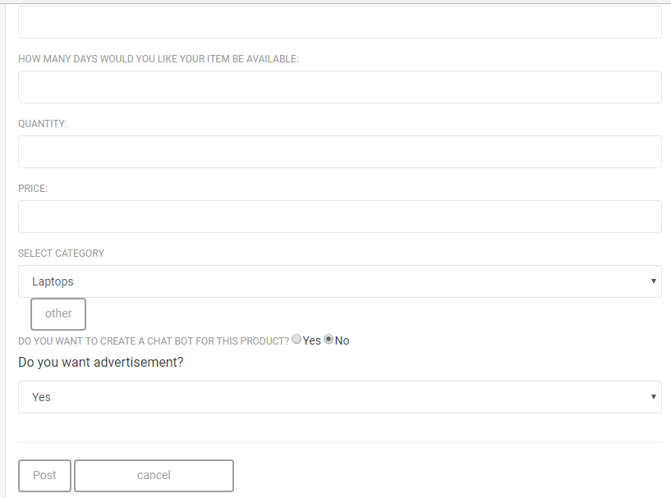

**To see the products on shola e-commerce**

Click the <category> dropdown box in the <shola> home page.

Once you clicked the category, all the category list under shola e-commerce will be display to you. Select one category list to see the available products lists for sale.